Fundamentals of Data Science - Assignment 4 Report

Program 1: NumPy Array Operations
This program creates a NumPy array and performs operations like sum, mean, maximum, and minimum.
Sample Output:
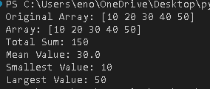

Program 2: List Sorting and Slicing
This program takes at least 12 numbers from the user, sorts them, and extracts elements using slicing.
Sample Output:
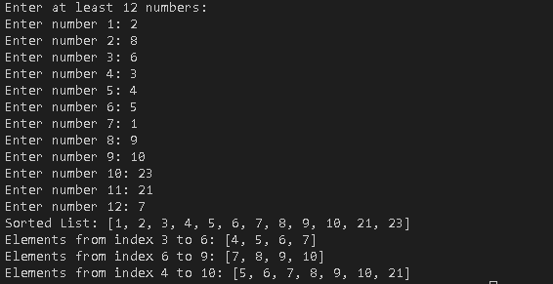

Program 3: Random Array and Reshape
This program generates a random array, sorts it, and reshapes it into a matrix.
Sample Output:
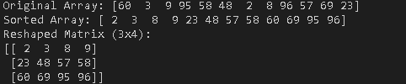

Program 4: Matrix Operations
This program takes two matrices as input and performs addition, subtraction, and multiplication with validation.
Sample Output:
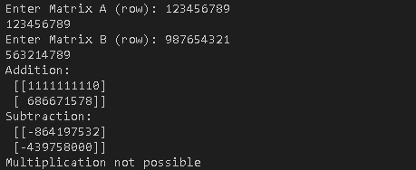

Program 5: Data Visualization
This program reads health_data.csv and creates scatter plots between variables like weight, height, age, and gender.
Sample Output:
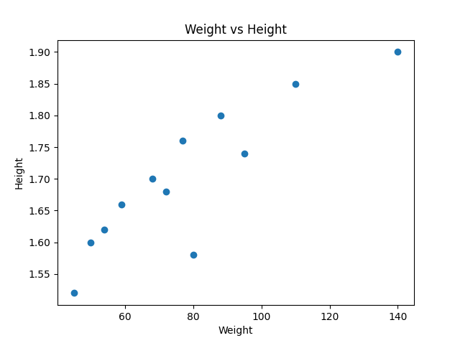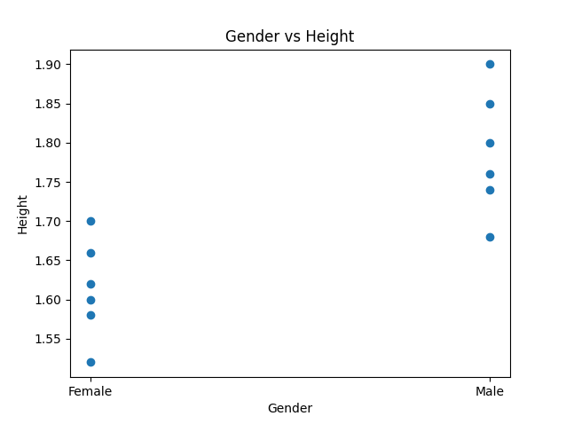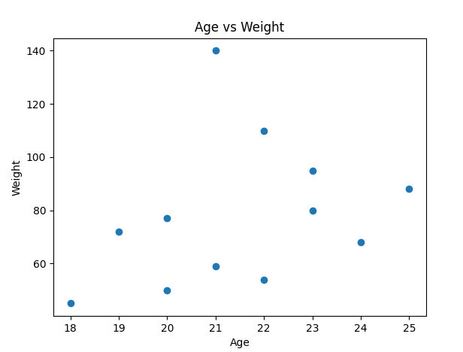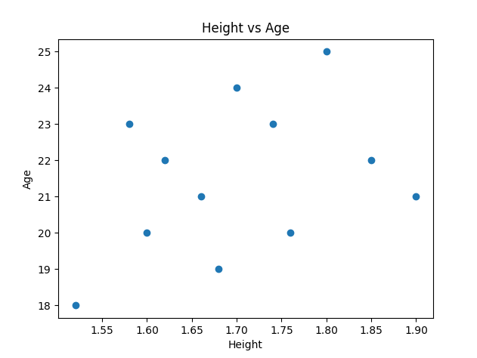
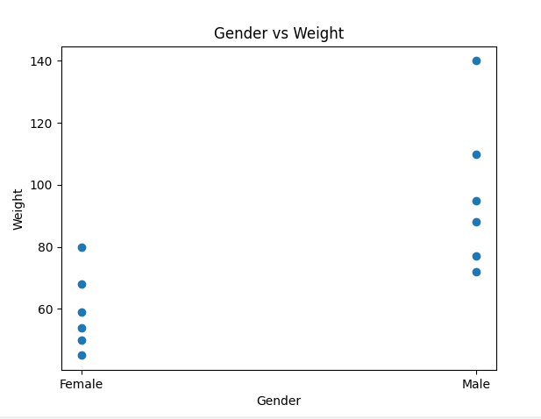

Program 6: BMI and Health Status
This program calculates BMI from the dataset and categorizes individuals into health status groups.
Sample Output:
